Phase 1 Report
Luke Moses
Cameron Mills

Currently there are 3 screens of the app roughed in. We have created a home screen, camera screen, and a friend selection screen. These screens are still rough designs but should reflect the overall direction of the app. Contained is a detailed report of current and expected progress.

User Stories
- If George would like to start a new game he can press the new game button and invite friends to play. Then he can take a picture and add a text hint and press a button to start the game.
- If Ben would like to guess on George's game, if he is invited he can select the game under the current games menu. If he thinks that he knows where the picture is taken he can take and upload a picture of the object to see if it is the same location. If it is he will receive Karma.
- If Sally follows the same process as Ben but beats him to the upload she will receive the Karma instead and Ben will get a loser screen. George will also receive some Karma when someone wins.
- As a new user Christo will have to log into Facebook via the integrated menu before he is allowed to add friends to play with.

Product Requirements
- Device
  - IOS/Android device
    - camera
    - network connectivity
    - GPS
- Server
  - Database
    - store images, text files, user profiles
  - processing
    - The server will compare GPS coordinates to judge if the guess is correct.
  - Uptime
    - the server will need to be available 24/7

Summary of progress and expectations
The final product will contain the following screens and features (difficulty x/10 and completion)
- A home screen to start a game or continue an old game. (3 completed)
- A Facebook login.(7 in progress)
- A screen of past users you have invited.(7)
- A screen to select Facebook friends to invite to a game.(7)
- A camera to take pictures of a location.(3 roughly completed)
- An approval page to approve the picture you take.(4)
- A text hint screen to add into the game, such as “downtown.”(4)
- A list for users to select games that are in progress.(5)
- A page for the owner to check guesses.(4)
- A page for the owner to confirm a winner.(4)
- A winner page to present someone with their Karma.(2)
- a Loser page to tell someone that their guess is bad.(2)
Stumbles
- getting the Facebook Login has been difficult but it is moving forward.

Current Screens
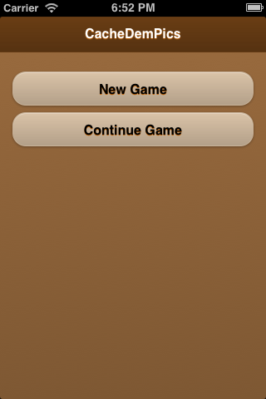
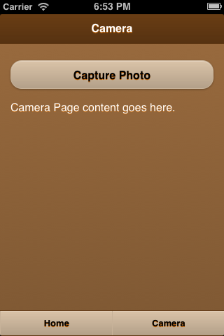
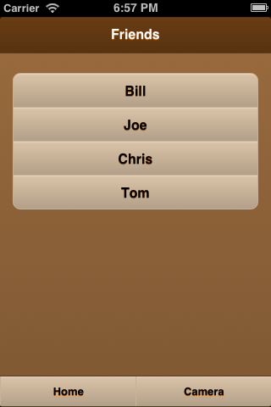
Planned Screens
